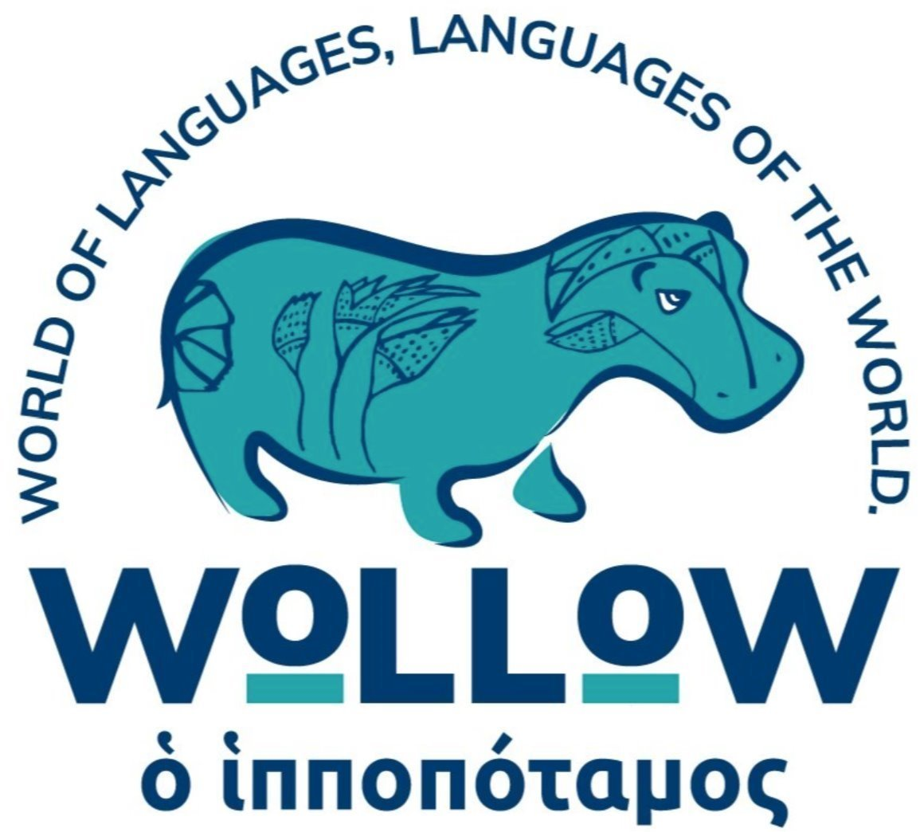

‘WoLLoW’: Highlights from the submission to the Curriculum Review.
November 2024
11. What aspects of the current a) curriculum, b) assessment system and c) qualification pathways should be targeted for improvements to better support and recognise educational progress for children and young people?
Since ‘WoLLoW’ is a KS2/KS3 languages programme, we will limit our input to language provision at those stages. However, we believe that language provision lies at the heart of what kind of society we want to live in when, for example:
‘according to the latest national census (2021), in London 40.6% of the population was born overseas, 57% of new babies had a non-UK born mother… and 20% of English primary school children use a language other than English at home.’
(Ben Rampton, Localising Linguistic Citizenship in England, Language Teaching (2023)).
There has been a narrative that multilingualism is a negative force and past governments have insisted on the necessity to learn English ‘for social cohesions and national security, and a lack of proficiency in the national language increases the threat of radicalisation.’ [Rampton ibid.]
However, there is an increasing awareness that respect for multilingualism and the rich diversity it can bring is not a negative force but an asset. (cf. Yaron Matras, Speech and the City, Cambridge 2024, passim)
Furthermore, there is clear evidence that pupils’ multilingualism is an asset in a wide variety of different ways, in economic and familial terms, in a sense of self-awareness, self-confidence and identity, and even, perhaps counter-intuitively in academic performance:
‘Findings reveal that multilingual learners initially face academic challenges at KS2, particularly in English and Science, but achieve comparable results with monolingual peers by KS4, overcoming early setbacks. Notably, simultaneous multilinguals not only catc up but excel beyond their monolingual counterparts by KS4, demonstrating the significant long-term academic benefits of early multilingual exposure and/or its associated cultural factors…. These findings underscore the need for educational policies that harness linguistic diversity foster academic success and equity. Research conducted in Canada… discovered that students who maintained a consistent use of their home language alongside English demonstrated better literacy outcomes…… This study supports the notion that sustained bilingualism contributes positively to academic performance, advocating for educational policies that promote maintaining the home language in the curriculum.’
[R. Filippi, The impact of multilingualism and socio-economic status on academic performance, International Journal of Bilingual Education and Bilingualism, September 2024]
And, finally, there is clear evidence that the preservation and development of multilingualism has material and long-term neurological benefits: cf., for example, Bak, TH and Mehmedbegovic D (2017) Healthy Linguistic Diet: the value of linguistic diversity and language learning across the lifespan.
(Language, Society and Policy, Vol 1. DOI: doi:10.17863/CAM.9854.)
All of this is significant, and much of it is new, reflecting the increasing diversity of the school population and extensive research. So, how does that relate to current provision? The National Curriculum has this is the purpose of the language provision:
‘A high-quality languages education should foster pupils’ curiosity and deepen their understanding of the world. The teaching should enable pupils to express their ideas and thoughts in another language and to understand and respond to its speakers, both in speech and in writing. It should also provide opportunities for them to communicate for practical purposes, learn new ways of thinking and read great literature in the original language. Language teaching should provide the foundation for learning further languages, equipping pupils to study and work in other countries.’
Two questions might be sensibly asked? Can it honestly and realistically be said that this is what the current provision offers or delivers? And, secondly, how can a statement about language provision make no reference to multilingualism, EAL or the relationship of languages to the related issues of literacy, oracy and English, or other curriculum subjects?
These issues were identified as part of the purpose of the NCLE: 'to improve transition from Key Stage 2 to Key Stage 3, to provide more opportunities for disadvantaged pupils and better recognise and support the rich diversity of languages spoken by one in every five of our pupils.' The British Academy's report, 'Towards a languages strategy' was singing a similar song – or lament - in 2020, specifying as an action to be undertaken in 1 to 5 years:
'We recommend further work to establish and then implement the best approach for the primary curriculum, and for the transition to secondary.'
Four years on, the problems persist:
'Whilst the intention behind compulsory Primary Languages in England was laudable, the reality of the challenges faced by the Modern Foreign Language (MFL) community in terms of staffing and organisation of primary languages and transition to secondary means that 10 years on, the policy is still struggling to translate into consistent practice.
'The Department for Education (DfE) Programmes of Study (PoS) for KS2 and KS3 are ambitious but vague aiming to encourage school autonomy and teachers’ freedom around the choice of language, curriculum time and model, subject content, pedagogy, and transition (DfE 2013). Unsurprisingly, given the significant demands standardised tests place on curriculum time and the lack of teacher expertise/training in the subject, the absence of precise requirements from the DfE has led to great variation in terms of provision (Finch, Katy, Anna Theakston, and Ludovica Serratrice. "Teaching modern foreign languages in multilingual classrooms: an examination of Key Stage 2 teachers’ experiences." The Language Learning Journal 2020, 48 (5)) and calls for greater clarity regarding pupils’ expected outcomes (Holmes, Bernardette, and Florence Myles. 2019. White Paper: Primary Languages Policy in England – The Way Forward. Outcome of RIPL Languages Policy Summit, RiPL Research in Primary Languages.) Indeed, this ‘very light touch governmental policy’ (Parrish, Abigail, and Ursula Lanver. 2019. "Student motivation, school policy choices and modern language study in England." The Language Learning Journal 47 (3)) fails to generate consistent practice (Collen, Ian. 2020. Language Trends 2020: Language teaching in primary and secondary schools in England. British Council), leaving Britain stubbornly stuck in ‘chronic monolingualism’ (Oxford: Higher Education Policy Institute. doi: https://www.hepi.ac.uk/wp-content/ uploads/2020/01/HEPI_A-Languages-Crisis_Report-123-FINAL.pdf.) despite a context of increasing linguistic diversity (Finch, Theakston and Serratrice, 2020).'
[Sophie Vazour: The World of Languages, Languages of the World: a pupils’ voice study on primary languages and multilingualism: article soon to be published in Language Learning Journal, 2024]
Furthermore, there is no conclusive evidence that the teaching of a single language, with the current amount of time commitment, is effective for pupils ats KS2:
‘Ample research shows that ‘early is best’ does not hold for children who are learning a foreign language in classrooms where time and input are limited. On the contrary, there is increasing evidence that limited-input instructional environments older learners learn more efficiently than younger learners.’
(Munoz and Spada, Foreign Language Learning from Early Childhood to Young Adulthood, The Cambridge Handbook of Bilingualism, Cambridge 2019)
And there is clear evidence of a lack of motivation (Parrish and Lanver, 2019), and a decline in motivation particularly in KS3 (Coleman, James A, Árpád Galaczi, and Lluïsa Astruc. 2007. "Motivation of UK school pupils towards foreign languages: a large-scale survey." The Language Learning Journal 35 (2)
‘The findings show that there is a decline in motivation to learn a foreign language over the course of the school year (Year 7). Repetition of material in secondary was pointed to as a strong demotivator for students.’
(Florence Myles, https://www.meits.org/files/policy_papers/uploads/Myles_JLSP_2017_.pdf).
And, finally, it may just be that there is a need for a much greater sense of realism, accepting what is actually possible with KS2 pupils in a short amount of timetable time – and no homework. The very design of the Mandarin Excellence Programme, 8 hours of work a week (4 hours in class and 4 on homework) is proof of that.
‘Even when students begin FL learning early, the limits of what can be achieved when little instructional time is provided even after several years are evident…. While testing experts estimate that 90-100 hours are required to reach an A1 level, some of these students had taken three to eight times more hours extended over many years to reach that level… among the several factors one can point to limitations in quantity and quality of exposure.’
(Munoz and Spada, Foreign Language Learning from Early Childhood to Young Adulthood, The Cambridge Handbook of Bilingualism, Cambridge 2019)
So, to return to KS2 and KS3, there is a need for a fundamental re-assessment of two closely related issues, the provision of languages at KS2 and the largely intractable issues of transition from KS2 to KS3 which lead to the indefensible position that almost all pupils start all over again in Year 7. And there are two more issues, the relation of language teaching to the wider issues of English, literacy and oracy, and the relationship between the linguistic diversity of our pupils and the languages they are taught. In the end, we need to ask why we are teaching what we are teaching, and why are we not teaching other things.
So, there is a clear need for a complete reappraisal of what is currently offered, guided by the answers to some fundamental questions:
- is the current commitment to 'competence in one language' the right approach?
- what is the best introduction to language study to children of this age?
- if specific languages are to be taught, which are the right ones in a new world of diversity?
- how does language teaching relate to the pre-existing language knowledge of the pupils?
- how can language provision support and develop the increasing multilingualism of our pupils?
- how does the teaching of languages relate to other aspects of the curriculum?
So, there is a need for an entirely new dispensation, viz.:
- a languages curriculum which encompasses, aligns and values all languages, English, 'MFL', 'heritage/family/community' languages, even 'classical languages'. Such an approach would address the problems of the hierarchy of languages and pupils: all pupils, could see the relationship, the connections and the worth of all languages.
- a languages curriculum which also encourages bilingual pupils to remain bilingual, rather than become monolingual and there is strong evidence that bilingual pupils perform better over time, even if they start from a position of disadvantage.
- a languages curriculum which links more closely to all other aspects of the curriculum, not only other curriculum subjects, but also literacy and oracy, PSHE, Equality, Diversity and Inclusion.
- a languages curriculum which conveys the value of languages and language awareness not only in economic terms, but in relation to cultural awareness, community cohesion, mutual understanding, a sense of identity and a sense of belonging.
Question 55: What else?
After all the theorising and the researching and the philosophising, our final contribution comes under the heading of practical wisdom. The ‘Call for Evidence’ has asked for ideas and solutions, not just lamentation and this is an ‘oven ready’, if not ‘already cooked’ deal. Over a period of years, four of us, all very experienced language teachers, have been working on a languages project, ‘WoLLoW’. Although we never intended this, ‘WoLLoW’ turns out to be an answer to many of the questions and problems in KS2/KS3 which are outlined in so much research and in this document. So, this is our solution.
Our mission statement goes like this:
Our mission is to bring the study of languages, all languages, into the centre of education. This is fundamental to society today for two reasons:
- This is a time when our schools have much greater linguistic diversity than ever.
- This increasingly diverse society has an urgent need to generate understanding, communication and respect between all people, and perhaps especially the young.
Our method is a complete languages curriculum for pupils in pupils aged between 7 and 13. It has been created by experienced language teachers, is available free to all schools, and aims to give value to the understanding of all languages. Thereby it brings together all the elements of a pupils’ experience in and out of school - and prepares pupils not only for future study, but future life.
Suitable for all abilities, and using a range of lively and appealing resources, created by teachers, the ‘WoLLoW’ curriculum addresses the following themes:
- curiosity, exploration and enjoyment – and not only for the pupils:
- an understanding of languages and thereby a development of literacy in a wider sense:
- communication, sharing, dialogue and oracy:
- a regard for all languages, modern, classical, heritage and, in particular, a celebration of multilingualism:
- a desire to preserve, value and study familial languages:
- an eagerness to study languages into the future.
- respect for each other’s history and culture:
- a sense of self-awareness and identity for pupils:
- a bridge between a pupil’s experience at school and their home life, and a bridge between parents and the school.
- an awareness of the relevance of languages not only to all school subjects but also to wider issues, such as migration.
It also has the additional advantages:
- its very nature of shared exploration means that it does not need to be taught by a languages specialist.
- it is inclusive in that it encourages contributions from all pupils and can thereby give a voice to EAL pupils.
- it is infinitely flexible so that it can be used as a curriculum in itself, or alongside the teaching of a language, as part of the English or PSHE curriculum, or in form period, or as the basis for a language club, or for special occasions.
- it is a particularly powerful tool in independent/state school partnership work in that it provides resources which can be taught by all teachers, whether team-teaching or not, or by senior pupils to younger pupils.
- it encourages collaboration between teachers from all subjects.
- it can be seen to work in a wide variety of different contexts: it is particularly effective as the language curriculum in special schools since it is adaptable and can play to the strengths of SEND pupils.
- we also have evidence that the progress that pupils have made can be assessed by an approach which explores their skills and attitudes as much as their knowledge.
- it enables the pupils and the school to engage with parents – and grandparents – and to make them, and their languages and histories part of the school.
Our website is https://theworldoflanguages.co.uk/ where there are examples of sample lessons and details can be found of the resources, which provide a complete language curriculum for KS2 and KS3 with 120 lessons already available.
Our resources have been downloaded by over 500 schools, equally divided between primary and secondary, state and independent, with a number of special schools and overseas schools also involved.
Responses to ‘WoLLoW’
Of course, we would say that ‘WoLLoW’ was a Good Thing, but the opinions of others might be more material. So, here goes:
- The conclusion of the research paper by De Sophie Vauzour, UEA.
‘The study suggests that ‘WoLLoW’ would have benefits for all students, in terms of motivation and metalinguistic awareness. ‘WoLLoW’ could provide an alternative to poor/inexistent provision in primary languages and transition, without affecting the pockets of excellent practice. Whilst larger scale and longer-term research would be beneficial to confirm the findings, participants’ responses are encouraging and suggest that ‘WoLLoW’ could also provide a fertile terrain for future language learning at secondary level and foster more positive attitudes regarding language learning and multilingualism. It is hoped that this study might facilitate discussions with policy makers, to explore the challenges of implementing the KS2 Programme of Study (Department for Education (DfE) 2013) in the current context, and the potential solutions such as ‘WoLLoW’, which might necessitate the rethinking and rephrasing of the Programme of Study.’

The research produced evidence that ‘WoLLoW’ had a positive impact on motivation to learn, competence, understanding, the pupils’ awareness of and regard for each other, and their interest in further language study.

- Teacher feedback over time.

A junior school teacher in Birmingham:
‘I am not a linguist by training, but by teaching ‘WoLLoW’ I have been able to awaken in the boys a real interest in two different, but related issues. The first is an understanding of how languages work. We’ve looked at a wide range of languages, from Greek to Punjabi, and seen fundamental similarities. We’ve talked about and deciphered different alphabets. We’ve thought about etymology, spelling, grammar and scientific/mathematical terminology. And all of this has led to the code-breaking world of the UK Linguistic Olympiad. The second is an interest in the relation between language and history and their own histories. ‘WoLLoW’ has encouraged the pupils to talk to the different generations in their families about their linguistic stories and to see how languages help us to understand the role of empires and migration. Thereby the pupils have actually engaged with what we might call ‘geopolitics’, an excellent polysyllabic Greek word.’
Soofia Amin. Assistant Head, Kensington Primary School, East London
‘We have around 650 pupils and about 50 languages. We have a very high mobility rate at Kensington Primary through the nature of the borough. Parents and families move here and move on quite quickly, so we have children joining us multiple times throughout the year. Already this week I think we've had six children joining us this week and last week we had about eight children. That is a strength because we have all these languages joining the school but also there's the challenge: how do we assimilate them quickly and help them access the curriculum, whilst at the same time getting the best out of their languages?
‘We quite quickly realised that multilingualism was much stronger than we realised. It was bringing a much clearer message and there was so much we could do as a whole school when it came to multilingualism. We got parents involved and we were working with the university last year on a multilingual story time. As part of this, we developed the curriculum with multilingualism. How do we do that? We added multilingualism, identity and languages into the curriculum.

‘In the Communication Curriculum, promoting first languages, it’s about how languages work, and the history of languages and all the other knowledge that ‘WoLLoW’ brings with it. The last thing that we hope children take from all of this is that they use all their languages. What we want is an approach for all children to use their languages as they are learning and they're proud of it and they're able to navigate learning using their own linguistic repertoires.

‘What did the parents learn from these sessions? One said, ‘We speak daily in Telugu but never thought of telling our child the Telugu numbers. This is a thought-provoking session.’ Another, ‘How important it is to promote our first language. I understand now that my child doesn't know how to write in Romanian. I will try to change it this.’ I just love this response. ‘It showed the importance of celebrating and engaging with non-English languages spoken at home in the school curriculum, not just from other ideological perspective, but from an academic one. It is fascinating to learn how children from multi-language backgrounds actually perform better in secondary level exams than those who identify as monolingual children.’

Rachel Quick, CEO, The Wherry School, Norwich

‘I'm the CEO of the Wherry School Trust. We are a specialist school for autistic young people that goes from 4 to 19. As a school, we are very different from the vast majority of special sector schools. Our children are those who are working and learning on a mainstream curriculum with a GCSE pathway as an aspiration for our students. The vast majority have come to us because of a significant breakdown in the relationships in their current settings. They all have all an autism diagnosis, and we know that that a significant aspect of that is around communication disorder with high levels of anxiety.

‘One of the things that we really aspired to when we set up the school was around this concept of the EBacc and why we have ended up with ‘WoLLoW’ is that we have reached a situation whereby we’ve got young people who are increasingly confident, independent learners but children who, through fear and disengagement, have a very negative attitude towards certain subjects. One of those was MFL subjects and we had very little engagement with GCSEs. So, introducing ‘WoLLoW’ was really about cultural education. What can we really do to move children on and to change their views? In MFL, we’ve got fear and anxiety around learning. We've got disordered communication as an aspect of the autism disorder which is a significant barrier for these young people. We needed to find some way just to celebrate languages and, like other schools, we came to ‘WoLLoW’. We wanted to find opportunities to embed and contextualise other learning, to work cooperatively, to give agency and autonomy to a child within their learning. We saw that the ‘WoLLoW’ approach was a phenomenal way of doing this. It allows our children to explore, to take their intense, personal interests and to become explorers whilst learning about languages. We first refer to it as a sort of like an Odyssey and we're going out on an adventure. We are going to really enjoy all these areas.’

Other comments:

‘’WoLLoW’s approach to learning languages works so well because it grows out of an understanding that most of our classrooms are already multilingual.’
‘Last year, we trialled ‘WoLLoW’ with years 3 to 6. The reaction from the students, in an ethnically and linguistically diverse school, was entirely positive. It sparked their curiosity about languages and, through recognition of heritage languages, made many feel even more included and valued.’

‘Teachers love teaching it, students love studying it. Not only that, but when speaking at our Curriculum Evening, it was clear that parents saw great value in ‘WoLLoW’. Parents whose first language is Greek, Urdu, Punjabi, Mandarin, Yoruba, made sure they saw me at the end to share their enthusiasm.’

‘It is clear is that when we return to French or Spanish lessons after a ‘WoLLoW’ lesson, links are being made and a deeper appreciation of languages and language learning is certainly evident’.

Who we are.
‘WoLLoW’, ‘World of Languages, Languages of the World’, is a languages project started in 2006 as a collaboration between:
- John Claughton, teacher of Latin and Greek since 1984, former Chief Master of King Edward’s School, Birmingham (2006-2016).
- Steffan Griffiths, teacher of Latin and Greek, Head of Norwich School
- Abbie Dean, teacher of German and Spanish (and ‘WoLLoW’), in both the independent and state sector.
- John Wilson, Head of MFL at Cheadle Hulme School and i/c Partnerships for ISMLA.
In addition, Kate Howell, Academic Director at HMC, and Dr Idnan Yunas, a GP in Birmingham are trustees. All of this has been made possible through the support of Norwich School, Cheadle Hulme School and a small number of donors.
Our allies
We believe that our work is closely related to other approaches to the issue of multilingualism in schools and society, such as:
- the work of Professor Yaron Matras, the founder of the Multilingual Manchester project, whose recent book, Speech and the City (Cambridge 2024), ‘describes the emergence of a city language narrative that embraces and celebrates multilingualism and helps forge a civic identity. He critiques discourses at a national level that regard multilingualism as deficient citizenship.’
- Linguistics in MfL, a project based at Newcastle University: https://linguisticsinmfl.co.uk/
- Manchester City of Languages: https://mcrcityoflanguages.org/
- Coalition for Language Education: https://coalitionforlanguageducationuk.com/
- Linguistics HQ: https://www.linguisticshq.co.uk/
- Association for Language Awareness: https://www.languageawareness.org/
- Healthy Linguistic Diet: https://healthylinguisticdiet.com/
- WAMCAM: https://www.wamcam.org/
- the multilingual curriculum at work at Kensington Primary School under the direction of Soofia Amin.
In developing these resources, we have worked not only with language teachers and heads at schools, but also with the following organisations and individuals:
- The universities of Manchester, Bristol, Cambridge, Birmingham, East Anglia, UCL, KCL, Oxford, Aston, Leicester.
- CLiE, Linguistic Diversity Collective (Manchester), MACFEST (Manchester), Linguistics in MFL, EAL Academy, Better Bilingual, the Stephen Spender Trust, the Schools of King Edward VI in Birmingham, Healthy Linguistic Diet, Birmingham Education Partnership, ASCL, UK Linguistics Olympiad, NCLE, the Oracy Commission, Languages Gateway, NALDIC.
- there have been two ‘WoLLoW’ conferences at which the following people have spoken:
- Professor Charles Forsdick (Cambridge University)
- Professor Wendy Ayres-Bennett (Cambridge University)
- Dr Robert Sharples (Bristol University)
- Dr Thomas Bak (Edinburgh University and
- Ms Qaisra Sharaz (founder of MACFEST)
- Ms Munira Alsusa (Founder, Manchester Arabic School)
- Andy Street (former Mayor of the West Midlands)
- Paula Rudd, Head of Water Mill Primary, Birmingham
- Graham Smith, Director EAL Academy
- we have attended conferences and present at events organised by the following organisations:
- APPG on Languages (July 2022)
- ALL
- HMC
- ISA SEND conference
- ISMLA
- Linguistic Cultural Diversity (Manchester)
- Schools Partnership Alliance
- Pixel Languages Conference, Florence 2023
https://conference.pixel-online.net/library_scheda.php?id_abs=6323&id_crs=1&id_edition=44&type=conference
- we have delivered the following webinars:
- a ‘WoLLoW’ webinar in which teachers from three primary schools described their use of ‘WoLLoW’:
- an ASCL webinar with Margaret Mulholland, i/c EAL and SEND at ASCL, and Soofia Amin, Deputy Head at Kensington Primary School.
https://www.ascl.org.uk/News/Podcasts/SEND-Bites
- a webinar with Geoff Barton, Director of the Oracy Commission.
https://open.spotify.com/episode/6oDDLwwaywTuh3Wn1KWSXG?si=Yksx0IUfQwqGKL13aoDGig&nd=1&dlsi=bace8e224db8448e
- ISA webinar
- we have visited many schools, of all different types.
- we have written lots of articles, including the following:
https://thelinguist.uberflip.com/the-linguist-archive/the-linguist-61-winter2022?p=14
https://thelinguist.uberflip.com/the-linguist-archive/the-linguist-62-4-winter-2023?p=32
‘WoLLoW’ in Independent Schools Magazine October 2024.pdf
John Claughton
Co-founder ‘WoLLoW’
November 2024

